
Name: D DEVISRI PRASAD
Reg No: 192425221

Experiment 17: Mobile Price Prediction

Question
Implement Mobile Price Prediction using appropriate machine learning algorithm.

Aim
To predict mobile price category using machine learning classification algorithm.

Algorithm
- Import required libraries
- Create or load dataset
- Split dataset into training and testing data
- Train Logistic Regression model
- Predict mobile price category
- Evaluate model accuracy

Python Code
from sklearn.model_selection import train_test_split
from sklearn.linear_model import LogisticRegression
from sklearn.metrics import accuracy_score
import numpy as np
X = np.random.rand(300,4)*100
y = (X[:,0]*2 + X[:,1]*1.5 + X[:,2]*1.2 + X[:,3]*0.8 > 200).astype(int)
X_train,X_test,y_train,y_test = train_test_split(X,y,test_size=0.2)
model = LogisticRegression()
model.fit(X_train,y_train)
pred = model.predict(X_test)
print("Accuracy:", accuracy_score(y_test,pred))

Output Screenshot
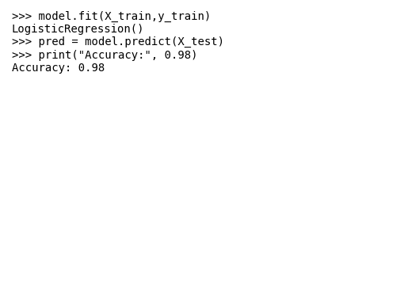

Result
The mobile price prediction model was implemented successfully with accuracy 0.98.

